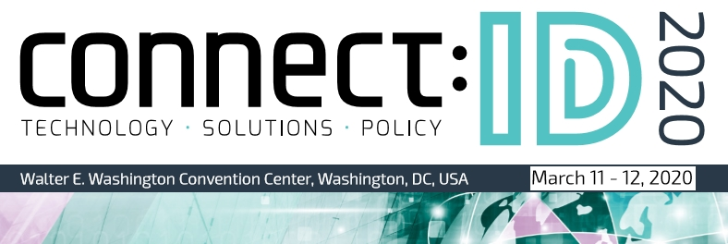

Speaker and Panelist Application Form
Thank you for contributing a proposal for connect:ID 2020. The event will take place from March 11th-12th 2020 in Washington DC. All speakers and panelists will be given a free pass to the conference and exhibition.

Proposals will be evaluated on the basis of relevance, content, originality and expertise/experience of the presenter. Any company/product promotional presentation will be rejected.

While all proposals will be considered on their merit, priority will be given to those representing governments, NGOS, end-user organisations, academia, standards/working groups and connect:ID sponsors. For sponsorship opportunities, please contact Janine Bill - j.bill@sciencemediapartners.com

Should your proposal be accepted, you will either be invited to deliver a standalone presentation (15 minutes including Q&A), or to sit on one of our expert panel discussions.

The deadline for receipt of proposals is August 14th, 2020

Applications and enquiries should be emailed to Laura Camplisson l.camplisson@sciencemediapartners.com

We will acknowledge receipt of all proposals and subsequently inform you if your application has been successful.

Theme
Please indicate on the list below which theme(s) best aligns with your proposal.

- Combatting Document Fraud
- Counterfeit trends, Physical security features, Fraud and forgery detection, Breeder Documents, Lookalikes, Design strategies
- Digital Identity Fraud
- Presentation-Attack-Detection, Account Takeover Fraud, Cybersecurity, Identity and the Dark Web, Bot Detection, Zero Trust Architecture
- Seamless Traveller Identity
- ‘Reservation to Destination, Known Traveller Identities, The use of biometrics, blockchain, Digital ID and AI, International Interoperability
- Securing Identity at the Border
- ‘Smart Borders’, Biometric exit/entry, automated border control processes, Databases and Data Analysis, Rapid DNA at the Border, Human Trafficking
- Privacy and Consent
- Transparency and Consent, Data Protection, Self-Sovereign Identity, The Ethics of Surveillance, Conflicting Privacy Models, Government regulation

- Biometrics at the Edge
- Standards, Variations in Accuracy across population groups, Impact of AI and Machine Learning on Algorithms, Biometrics at a Distance, Contactless Technology
- Trusted Identity
- Identity Proofing, KYC/AML, Online Authentication, Remote Onboarding, Behavioural analytics, Federated Identity
- The Future of IAM
- Customer IAM, Open Source/Commercial IAM Insider Threat Detection, Privileged Access Management, User Experience, Cloud Based Identity
- Smart Credentials
- eID Cards and Services, Future eTravel Credentials, PIV Developments, PKI, REAL ID, Biometric Smart Cards, Access Control
- Mobile ID
- Derived Credentials, Citizen Mobile ID, Mobile Authentication, The Impact of 5G, Biometrics on Mobile, mDLs
- Identity for All
- Foundational identity, National registries, Reaching Rural Areas, Humanitarian efforts, Secure voting, Securing large Biometric databases
- Securing Citizens
- Law enforcement, Smart Safe Cities, Counter-Terrorism, Disaster Response, Military/Defence Biometrics, National Cybersecurity

Proposal Title
Try to keep this short, snappy and descriptive

Name of Participant
Note we do not include qualifications/affiliations appearing after a speaker's name

Job title of Participant
Where there are multiple job titles, please only include the one most relevant for this event

Contact Details
Organisation name

Address

Telephone number

Email address

Proposal Bullet Points
Please provide three one-line bullet points that summarize your proposal and can be printed in the Conference Guide

Proposal Summary
This should not exceed 100 words. It will be edited and published online/ in the Conference Guide if your proposal is accepted

Short Professional Biography
Please provide a short biography relevant to this event. This should not exceed 200 words

Date Restrictions
Please indicate if you are unable to partake on either of the following dates:

- Wednesday March 11th
- Thursday March 12th

Preferred Format
While it is not possible for us to guarantee the format, please indicate whether you would prefer a standalone presentation, to sit on a panel or either

- Presentation
- Expert Panel
- No Preference

Photo of Participant
Please provide a color headshot of the participant in jpg format at a resolution suitable for printing (ideally 300dpi)

