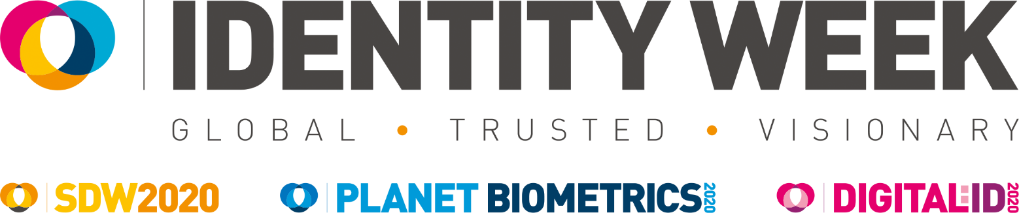

Speaker and Panellist Application Form

Many thanks for contributing a proposal for Identity Week 2020. The event will take place from 9th to 11th June 2020 at ExCeL London. Speakers will be given free entrance to the conference and exhibition.

Proposals will be evaluated on the basis of relevance, content, originality and expertise/experience of the presenter. Any company/product promotional presentation will be rejected.

While all proposals will be considered on their merit, priority will be given to those representing governments, end user organisations, NGOs, academia, standards/working groups and sponsors. For sponsorship opportunities please contact Janine Bill - j.bill@sciencemediapartners.com.

Should your proposal be accepted you will either be invited to deliver a standalone presentation (15 minutes plus Q&A) or to sit on one of our expert panel discussions.

We will acknowledge receipt of all proposals and subsequently inform you if your application has been successful.

The deadline for receipt of proposals is Wednesday, 23rd October 2019

Applications and enquiries should be emailed to Sam Dolton - s,dolton@sciencemediapartners.com

Theme
Please tick which session best aligns with your proposal. Example themes can be found below.

SDW 2020:
☐ Designing Secure Documents - Developing Key Physical Features
ICAO Compliance, Graphical Features, Security Printing

☐ Digital Transformation of Credentials
Mobile ID, Derived Credentials, Next Gen Driving Licences

☐ Passports in the Cloud and Beyond
ePassports, PKI, Digital Travel Credentials

☐ Document Fraud In Focus - Prevention, Detection, Disruption
Breeder Documents, Authentication, Morphing

☐ Refining the Enrollment and Issuance Process
Protecting Document Integrity, Customer Services, Personalisation

☐ Establishing an Identity Lifecycle
Identity Origins, Civil Registration, Citizen ID

Planet Biometrics 2020:
☐ Biometrics in Law Enforcement
Rapid DNA, Safe Cities, Counter-Terrorism

☐ Key Trends in Biometric Payments and Retail
Sensor-on-Card, Mobile Payments, Online Transactions

☐ Biometrics and Narrowing the Identity Divide
Citizen Services, Inclusivity, Persona Testing

☐ Leveraging the Power of Biometrics in Government
Secure Voting, Biometric Databases, Ethics and Consent

☐ Biometrics for Humanitarian Aid
Disaster Relief, Refugee Registration, Immunisation Coverage

☐ Standards and Testing
ISO Standards, Accuracy and Bias, Scenario Testing

Digital:ID 2020:
☐ Combating Digital Identity Fraud
Synthetic IDs, The Darknet, Presentation Attack Detection

☐ Developing Digital Identity Standards
Interoperability, Compatibility, Assurance

☐ What Next for National ID Schemes?
eID Schemes, Digital Citizen Identity, eGovernment Services

☐ Digital Identity in Financial Services
Remote Onboarding, Trust Frameworks, Open Banking

☐ Digital Identity on the Blockchain
Self-Sovereign Identity, Regulation, Privacy

☐ Proofing and Authentication in the Digital World
FIDO Standards, PSD2, KYC/AML5

Summit Theatre:
New for 2020, there will be two full one-day summits which will focus specifically on one targeted area of identity.

☐ Reimagining IAM
Governance, Decentralised Identity, Cyber Security, CIAM, Hybrid IAM

☐ Traveller Identity
End-To-End Passenger Experience, MRTDs, Biometrics at the Border, Entry/Exit System, Risk Management

Name of Participant
Note we do not include qualifications/affiliations appearing after a speaker's name

Job title of Participant
Where there are multiple job titles, please only include the one most relevant for this event

Contact Details
Organisation name

Address

Telephone number

Email address

Proposal Title
Try to keep this short, snappy and descriptive

Proposal Bullet Points
Please provide three one-line bullet points that summarize your proposal and can be printed in the Conference Guide

Proposal Summary
This should not exceed 100 words. It will be edited and published online/ in the Conference Guide if your proposal is accepted

Short Professional Biography
Please provide a short biography relevant to this event. This should not exceed 200 words

Speaking Experience
If possible please let us know of any previous events you have spoken at and/or links to video or audio recordings

Date Restrictions
Please indicate if you are unable to partake on any of the following dates:

☐ Tuesday 9th June
☐ Wednesday 10th June
☐ Thursday 11th June

Preferred Format
While it is not possible for us to guarantee the format, please indicate whether you would prefer a standalone presentation, to sit on a panel or either

☐ Presentation
☐ Expert Panel
☐ No Preference

Photo of Participant
Please provide a square, colour headshot of the participant in .jpg format at a resolution suitable for printing (ideally 300dpi)

