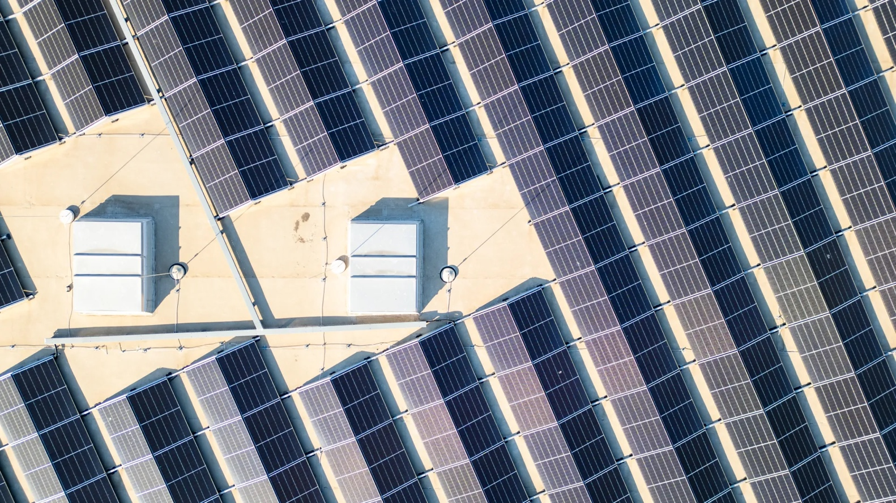
Harnessing the Sun: The Middle East’s Shift to Solar Power and Storage
By Chief Product Officer, Saqib Saeed and Research Analyst, Siddiqa Batool– at PTR Inc.
- The Middle East is increasingly investing in renewable energy to reduce dependence on fossil fuels, with countries like Saudi Arabia, the UAE, and Qatar setting ambitious targets for solar and wind power, supported by large-scale energy storage initiatives.
- Energy storage is a critical component of the transition, addressing the intermittency of solar and wind power. Battery Energy Storage Systems (BESS) are emerging as a preferred solution over traditional methods like pumped hydro storage due to their scalability and flexibility.
- Challenges remain in scaling renewable energy, including grid stability issues, extreme climate conditions affecting battery performance, and the need for regulatory and policy support. However, continued investment and technological advancements position the region as a potential global leader in clean energy innovation.
The global shift from fossil fuels to renewable energy is crucial in combating climate change, yet fossil fuels still supply 80% of the world’s energy needs. Ensuring this transition is just—rooted in equity, inclusion, and sustainable development—is vital for delivering broad-based benefits. Progress hinges on scaling renewable energy and storage, decarbonizing high-emission sectors, improving energy efficiency, and implementing supportive policies alongside innovative financing mechanisms.
The Middle East, historically a key supplier of fossil fuels, is now positioned to play a pivotal role in advancing the energy transition. Gulf Cooperation Council (GCC) countries are actively diversifying their economies to reduce dependence on oil and gas. Initiatives such as Saudi Arabia’s Vision 2030 and the UAE’s Energy Strategy 2050 reflect strong commitments to renewable energy adoption and sustainable technologies.

Solar Power: A Cornerstone of Transition
Solar power is central to this transformation. With abundant sunlight, competitive labor costs, and falling hardware prices, countries like Saudi Arabia have achieved record-low levelized costs of electricity (LCOE) from solar photovoltaics—reaching USD 10.4 per megawatt-hour. Exceptional solar potential—exceeding 2,000 kWh per square meter annually in Saudi Arabia, the UAE, and Oman—positions the region as a potential global leader in solar energy.
To unlock this potential, energy storage has become increasingly critical. Storage technologies such as batteries enable reliable, round-the-clock power by integrating variable solar energy into the grid. Recognizing this, Middle Eastern nations are investing in both large-scale solar projects and energy storage infrastructure. This dual focus enhances grid stability, strengthens energy security, and supports ambitions to lead in clean energy innovation—contributing meaningfully to global climate goals.

Current State of Renewable Energy Adoption
Energy systems in the Middle East remain predominantly reliant on oil and gas, with natural gas accounting for 76% of power generation in 2024 and other fossil fuels contributing 18%. Coal plays a negligible role. Despite vast renewable resources, most countries in the region have yet to make significant strides in clean electricity adoption. Solar and wind collectively represent less than 1% of the energy mix in countries such as Bahrain, Iran, Iraq, Kuwait, Lebanon, Oman, Qatar, and Saudi Arabia.
Saudi Arabia, however, is embarking on a transformative path to become a major player in the global renewable energy sector. The Kingdom aims to source 50% of its electricity from renewables by 2030—one of the most ambitious renewable scale-ups worldwide, though the roadmap to implementation remains evolving. Jordan stands out in the region, generating 28.2% of its electricity from wind and solar by the third quarter of 2024.
Saudi Arabia’s commitment is embedded in its National Renewable Energy Program, which seeks to diversify the energy portfolio and reduce dependence on fossil fuels. By 2030, the Kingdom aims to generate 58.7 GW of renewable energy capacity, comprising 40 GW from solar PV, 16 GW from wind, and 2.7 GW from concentrated solar power (CSP). Between 2022 and early 2024, Saudi Arabia added 2.1 GW of renewable capacity—a 300% increase from the 700 MW added between 2012 and 2022.
The UAE’s updated strategy outlines a phased national program to meet rising energy demand while preserving natural resources. By 2030, the UAE plans to:
- Reduce emissions from the water and energy sectors, targeting net zero by 2050.
- Eliminate clean coal from its energy mix to align with climate neutrality objectives.
- Improve energy efficiency across sectors by 42–45% compared to 2019.
- Triple the share of renewable energy in the mix.
- Increase installed clean energy capacity from 14.2 GW to 19.8 GW.
- Raise clean energy’s share in the total energy mix to 30%.
Qatar has set a target of deploying 4 GW of utility-scale renewable energy capacity—primarily solar PV—by 2030, aiming to raise renewables’ share in its energy mix from 5% to 18%. This transition will require an estimated USD 7.6 billion investment. Additionally, Qatar aims to achieve 200 MW of distributed renewable energy generation, enabling customers to install solar PV systems for self-consumption and grid export.
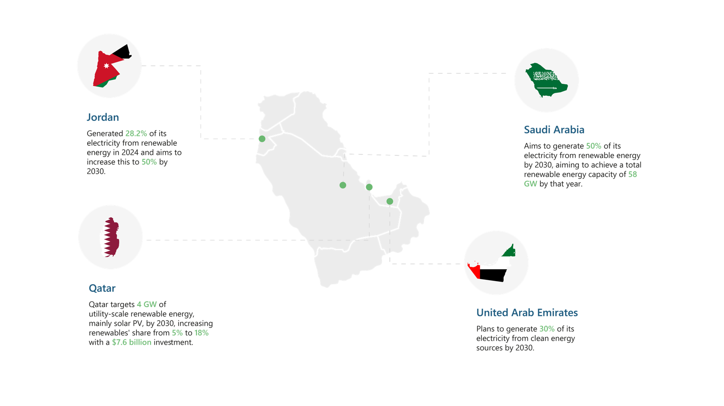
Figure 1: Renewable energy targets set by countries in the Middle East.
Source: PTR Inc.

Challenges in Scaling Renewable Energy
The region benefits from abundant solar resources and vast expanses of uninhabited land ideal for solar and wind development. Over time, the renewable sector could support international energy trade, particularly with Europe seeking to import low-carbon energy from North Africa via Mediterranean pipelines. Green hydrogen and derivatives like green ammonia could also be exported globally.
However, scaling up renewables presents challenges, particularly for grid operators. The intermittent nature of solar and wind generation necessitates reliable baseload power to maintain continuous electricity supply. As renewable capacity grows, the need for advanced energy storage solutions becomes critical to balance supply and demand effectively.
Traditional storage solutions such as pumped hydro storage (PHS) and CSP have provided foundational support, but limitations in flexibility and scalability are prompting a shift toward battery energy storage systems (BESS). These systems offer quicker deployment, modular design, and adaptability to diverse grid needs.

Emerging Energy Storage Projects in the Middle East
The Saudi Power Procurement Company (SPPC) is preparing to launch procurement for an initial 2,000 MW phase of a BESS project, aiming for up to 10 GW (40 GWh) of BESS capacity by 2030. These projects aim to support solar integration in the Kingdom. The UAE has announced a USD 6 billion, 5 GW solar plant integrated with a 19 GWh battery storage system, designed to provide 1 GW of continuous power output. Plans are underway to add BESS to the 500 MW Ibri III Solar Independent Power Project (IPP), along with the 100 MW North Solar Storage PV plant featuring Oman’s first lithium-ion battery system.
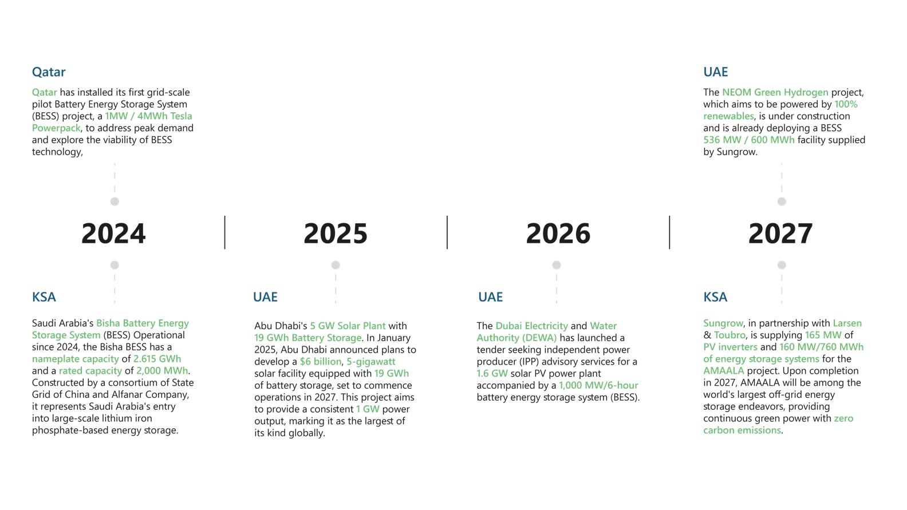
Figure 2: Key energy storage projects in the Middle East.
Source: PTR Inc.

Technological Considerations for Energy Storage
Energy storage technology selection in the MENA region depends on several factors, including site conditions, grid requirements, regulatory frameworks, and cost. Technologies such as sodium-sulfur (NaS), lithium-ion (Li-ion), and flow batteries are being deployed for short- to medium-duration storage. However, Li-ion batteries face performance challenges in the region’s extreme heat, which can impair efficiency and lifespan.
These conditions are driving interest in alternative technologies, including vanadium redox flow batteries, which offer longer storage durations, lower degradation, and greater temperature tolerance—making them promising solutions for specific applications in the region’s harsh climate.

Future Outlook
The Middle East will utilize its renewable energy potential and see strong growth in BESS. Countries like Saudi Arabia, the UAE, and Qatar will emerge as key players in the region’s BESS market. Government support and investments will drive large-scale storage projects, making BESS a crucial part of the energy transition. As a result, the Middle East will become one of the fastest-growing markets for BESS, with strong market growth.
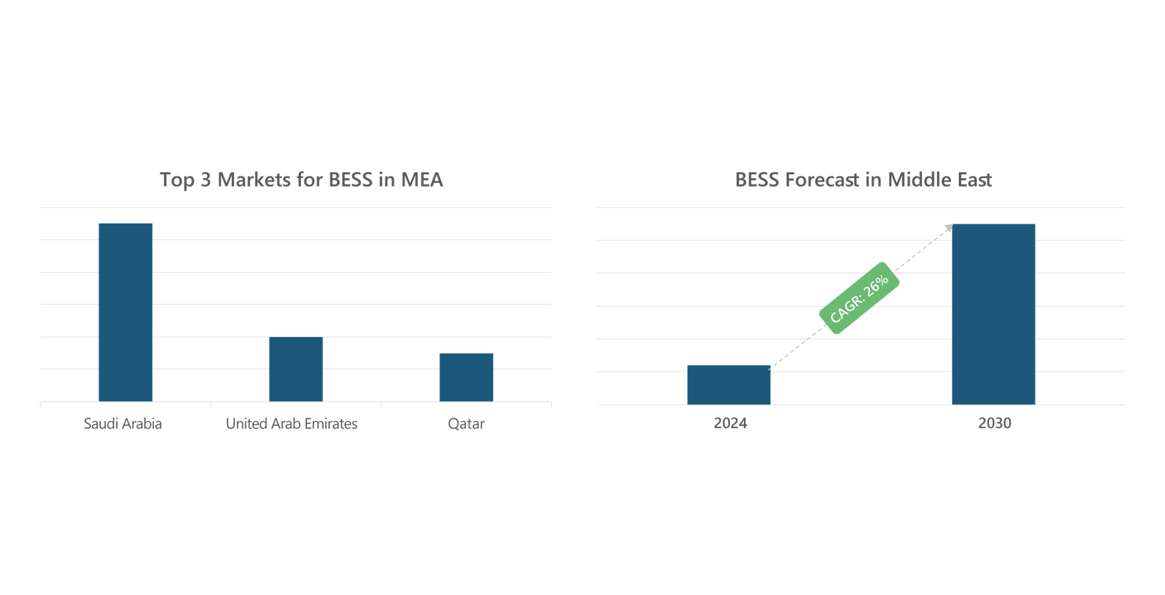
Figure 3: Future Outlook for BESS Growth in the Middle East
Source: PTR Inc.

Conclusion
The Middle East is at a pivotal moment in its energy transition. Harnessing its unparalleled solar resources and advancing energy storage solutions can position the region as a leader in clean energy innovation. While significant challenges remain—especially in scaling renewables and ensuring grid stability—ongoing investments and technological adaptation signal a strong commitment to building a sustainable energy future that aligns with global climate objectives.
About the Author

Saqib Saeed
Chief Product Officer - PTR Inc.
Saqib is a highly accomplished market research professional and a data storyteller in the international energy industry. With over a decade of experience in the field, he currently serves as the Chief Product Officer at PTR Inc. His expertise lies in the power grid and e-mobility equipment sectors. Saqib has overseen numerous global market research studies throughout his career and provided valuable insights to key decision-makers at various Fortune 500 companies. He is a member of the editorial board for Transformers Magazine and a member of the Advisory board of CWIEME Berlin and Middle East Energy. In addition to his market research career, Saqib has worked as an Electrical Engineer in the manufacturing sector.

Siddiqa Batool
Research Analyst - PTR Inc.
Siddiqa Batool is a Research & Market Analyst at PTR Inc, with a focus on the topic of energy storage. Her research includes analyzing market developments regarding energy storage, ranging from legislative landscapes to business cases, installations, pipeline projects, and the developments in battery chemistries and their supply chain. She has also undertaken custom projects on the topic of energy storage, further advancing her knowledge and research on the topic. She has a bachelor's degree in electrical engineering from Mehran, UET, which brings the value of technical background to her role as a market analyst.
About PTR: With over a decade of experience in the Power Grid and New Energy sectors, PTR Inc. has evolved from a core market research firm into a comprehensive Strategic Growth Partner, empowering clients’ transitions and growth in the energy landscape and E-mobility, particularly within the electrical infrastructure manufacturing space.
Contact:
(sales@ptr.inc)

